What Determines a Football Player’s Market Value?

DSA 210 Final Project Report

Ardıl Öner

Sabancı University
DSA 210 – Introduction to Data Science
- May 2026

1.Introduction

Football player market values are influenced by many different factors such as performance statistics, age, league quality, popularity, and transfer market conditions.

In this project, we aimed to analyze which factors are related to player market value by using football datasets collected from different sources. We combined player statistics and FIFA rating data to perform exploratory data analysis, hypothesis testing, and machine learning applications.

Our main goal was to understand whether performance statistics alone are enough to explain a player's market value and to observe which variables have stronger relationships with market value.

2.Data Sources

We used two different datasets in this project.

The first dataset included football player statistics such as goals scored, assists, minutes played, appearances, and league information.

The second dataset included FIFA player ratings such as overall rating, potential, pace, shooting, passing, dribbling, defending, and physical attributes.

The datasets were merged using player names in order to create a richer dataset for analysis.

3. Data Cleaning and Preprocessing

Before starting the analysis, several preprocessing steps were applied to the datasets.

Missing values were removed from important columns used in the analysis. Some columns had different formats, especially the market value column, which was converted into numerical form.

The datasets were merged using player names, and unnecessary columns were removed after merging.

After preprocessing, the final dataset was used for exploratory data analysis, hypothesis testing, and machine learning models.

4. Exploratory Data Analysis (EDA)

We performed exploratory data analysis to better understand the distribution of the variables and the relationships inside the dataset.

Several visualizations were created to analyze player statistics and market values.

Figure 1 shows the relationship between goals scored and player market value. The graph suggests that players who score more goals generally tend to have higher market values, although there are still some exceptions.

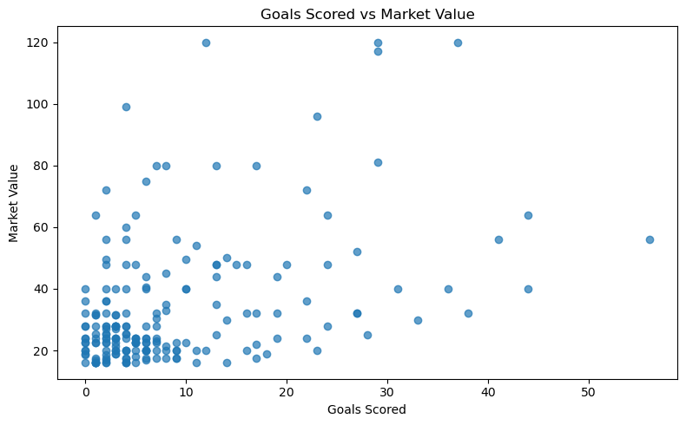

Figure 1. Relationship between goals scored and market value

Figure 2 presents the age distribution of the players included in the dataset. Most players are concentrated between the ages of 21 and 27.

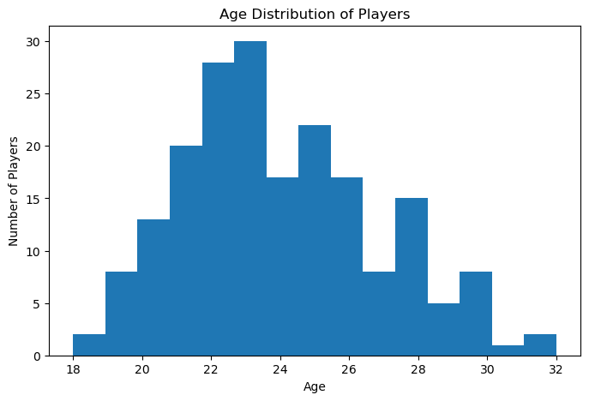

Figure 2. Age distribution of players

Figure 3 shows the number of players by league. The Premier League had the highest number of players in the dataset compared to the other leagues.

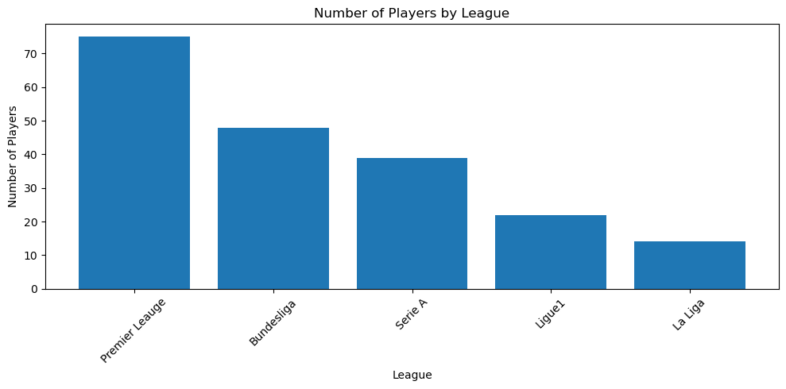

Figure 3. Distribution of players by league

5. Hypothesis Testing and Findings

We performed hypothesis testing to analyze the relationships between several variables and player market value.

The relationship between goals scored and market value was found to be statistically significant and positive. Players who scored more goals generally tended to have higher market values.

On the other hand, some variables such as age and league differences did not show statistically significant relationships in our analysis.

These findings suggest that offensive performance indicators, especially goal scoring, are more strongly associated with market value compared to some demographic variables.

6. Machine Learning

Model | MAE | RMSE | R square
Linear Regression | 9.75 | 12.06 | 0.39
Random Forest | 9.60 | 12.65 | 0.33

In this part of the project, we tried to predict players’ market value using performance statistics.

We tested two different models:
- Linear Regression
- Random Forest Regressor

To evaluate the models, we used:
- MAE (Mean Absolute Error)
- RMSE (Root Mean Squared Error)
- R² score

The results showed that Linear Regression performed slightly better than Random Forest in terms of R² and RMSE.

However, both models had relatively low R² scores. This indicates that player market value cannot be fully explained only by performance statistics.

External factors such as popularity, transfer market conditions, team success, and league prestige likely play an important role in determining market value.

7. Limitations and Future Work

One limitation of this project is the relatively limited size of the dataset. In addition, some important variables that may affect market value, such as player popularity, injury history, and social media influence, were not included in the analysis.

Future studies could improve the prediction performance by using larger datasets and adding more detailed player information.

Additional machine learning methods and feature engineering techniques could also be explored in future work.

8. Conclusion

Overall, this project provided useful insights into the factors affecting football player market value.

The analysis showed that performance statistics, especially goals scored, are related to market value. However, market value is influenced by many additional factors beyond on-field statistics.

The project also demonstrated how data science techniques such as exploratory data analysis, hypothesis testing, visualization, and machine learning can be applied to real-world sports data.

9. AI Assistance

AI-based tools were used during the project to support grammar correction, report organization, and code debugging.

The final analysis, interpretations, visualizations, and project decisions were completed and reviewed by the student.

10. References

- Kaggle. Football Player Market Value Dataset.
- FIFA Player Statistics Dataset.
- Python Libraries: pandas, matplotlib, scipy, scikit-learn.

